Contents

Automation of Custom Metadata & Lineage Extraction into EDC 2

Components Involved 2

Lineage_input.csv 2

IDQ Workflow 2

Trigger Workflow 3

Create Custom Model and Custom Resource Type 3

Create Custom Model 3

Create Custom Resource with Custom Model 3

Create Custom Metadata Resource 4

Create Lineage Resource 4

Run/Schedule the EDC Resource 5

Metadata Resource 5

Lineage Resource 6

Lineage Extracted into EDC 6

Implementation Steps with Artifacts 7

# Automation of Custom Metadata & Lineage Extraction into EDC

## Components Involved

### Lineage_input.csv

This is the input lineage file which will be used for extraction link/object and lineage file that will extract transformation logic and lineage into EDC

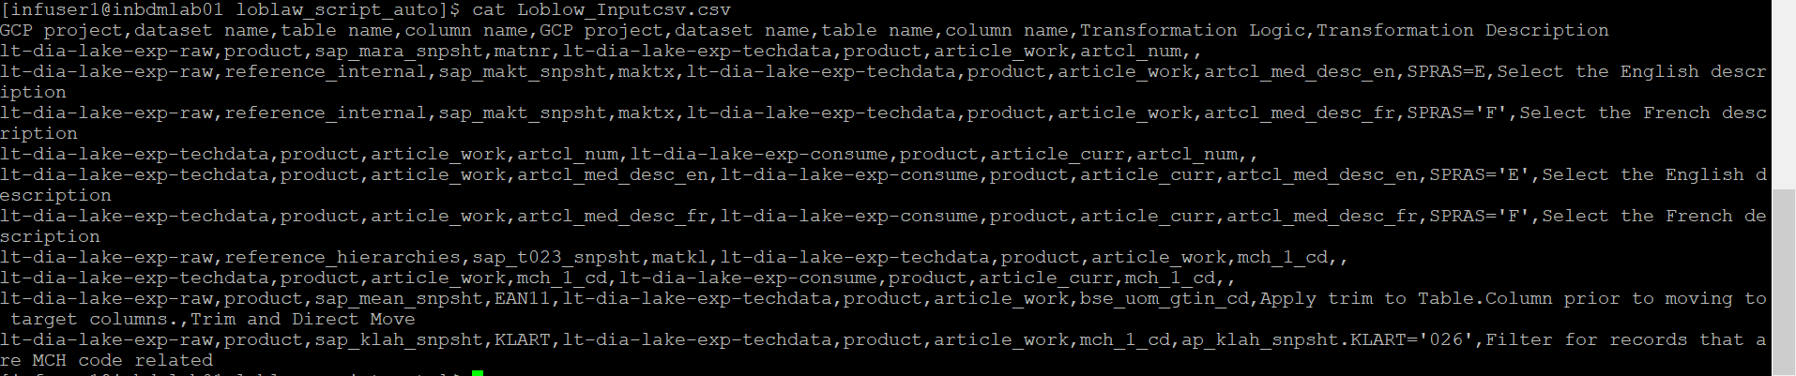

### IDQ Workflow

Which contains three mappings, and a command task will create links.csv, objects.csv, lineage_output.csv and objects.zip file

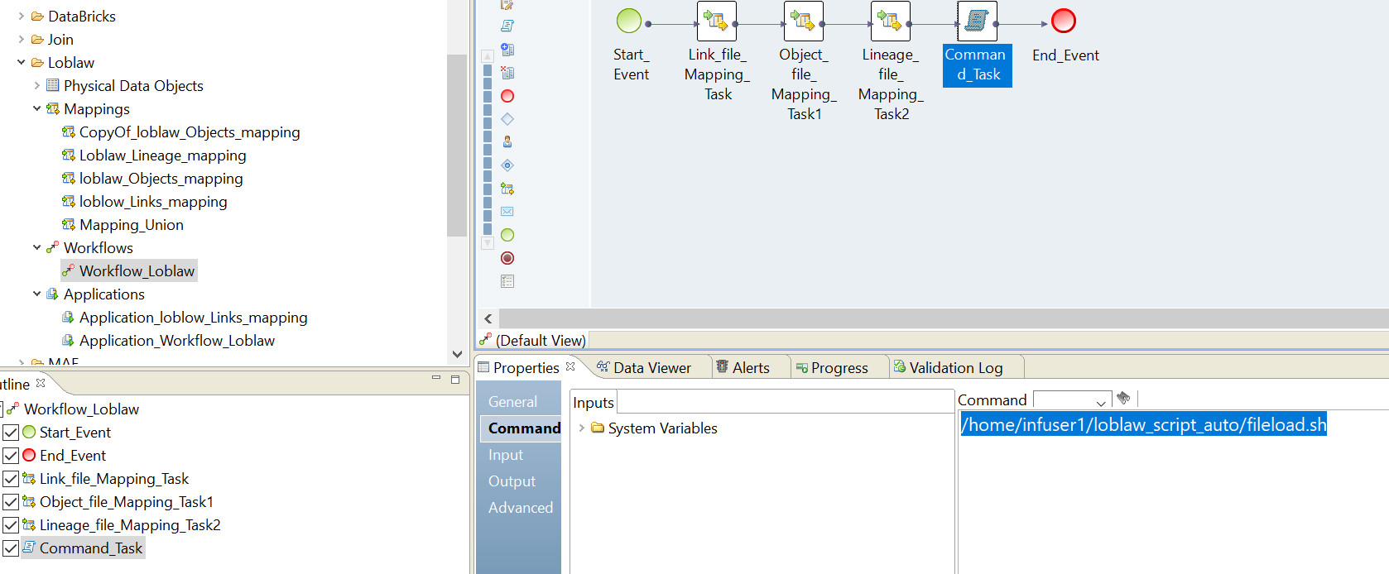

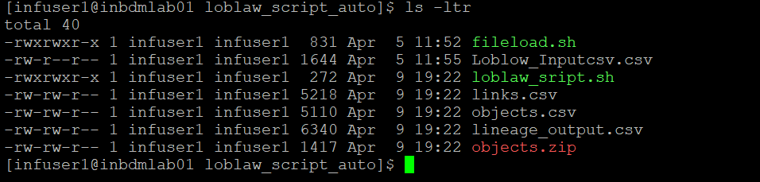

### Trigger Workflow

This will run the workflow, which will create the output file and upload into EDC



## Create Custom Model and Custom Resource Type

### Create Custom Model

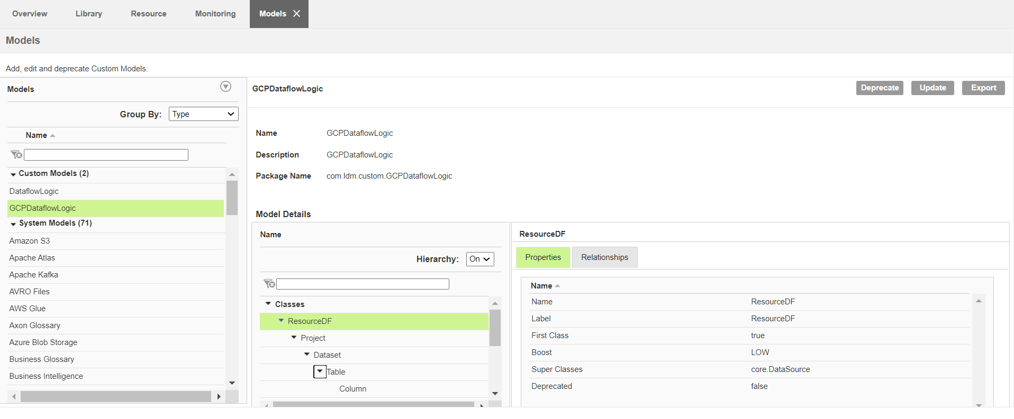

### Create Custom Resource with Custom Model

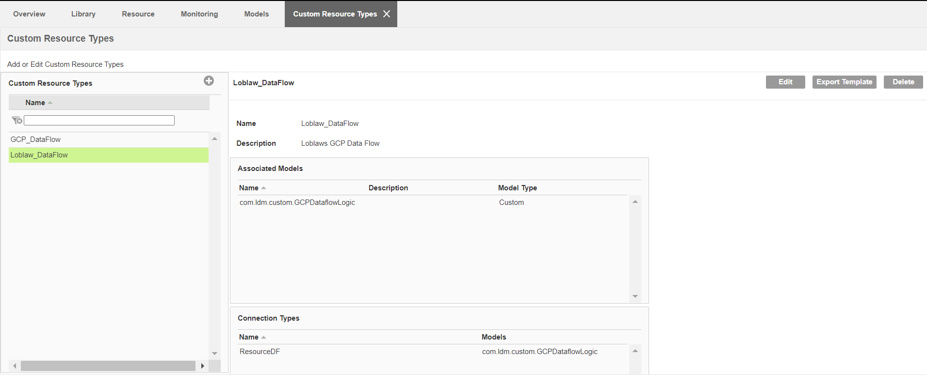

### Create Custom Metadata Resource

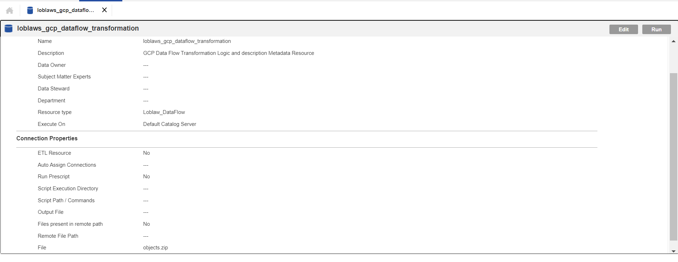

### Create Lineage Resource

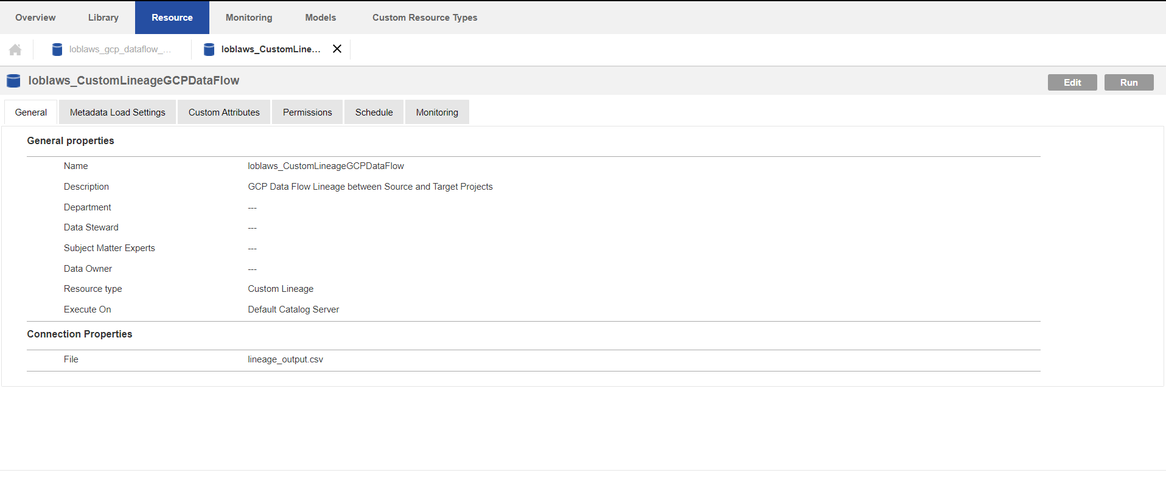

## Run/Schedule the EDC Resource

### Metadata Resource

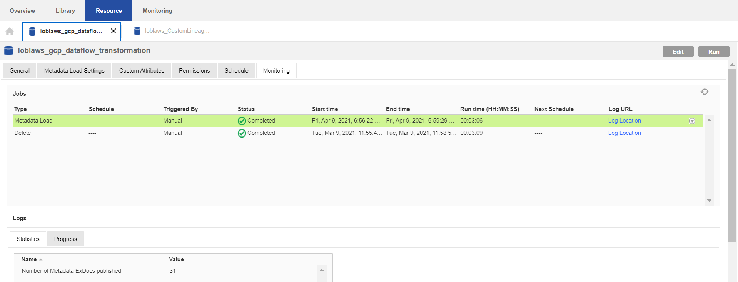

### Lineage Resource

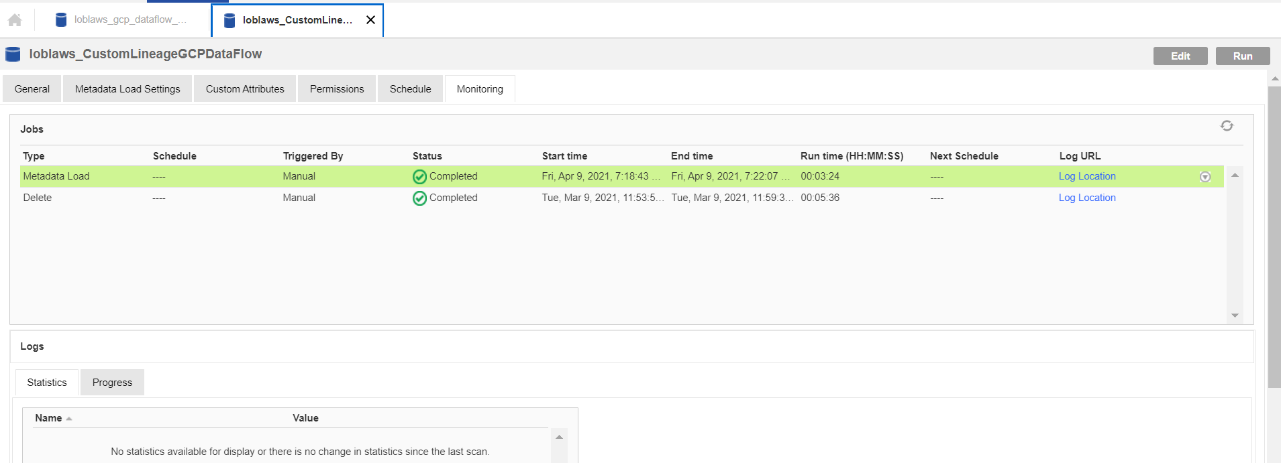

## Lineage Extracted into EDC

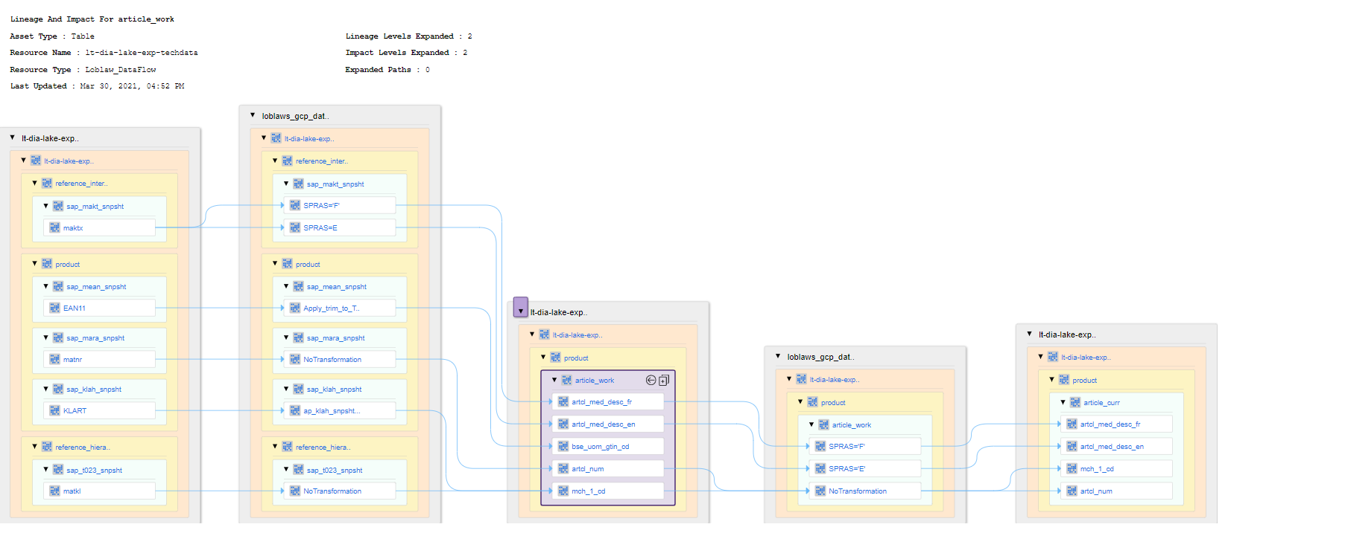

## Implementation Steps with Artifacts

|  |  |  |
| --- | --- | --- |
| Sno. | Implementation Step | Artifacts |
| 1 | Create Custom Metadata Model |  |
| 2 | Create Custom Resource Type and Resources | NA |
| 3 | Create Custom Metadata Scanner for showing transformation logic |  |
| 4 | Create Custom Lineage Scanner for showing Lineage |  |
| 5 | IDQ 10.4.1 Workflow to be imported |  |
| 6 | Need to do changes in Path’s of input/output file as needed | NA |
| 7 | Run Workflow to create EDC input files and upload the files to EDC |  |
| 8 | Need to modify loblaw and fileload scripts to match IDQ environment & service, And also change curl command to reflect your environment | NA |
| 9 | Input file for IDQ mapping |  |
| 10 | If IDQ mapping needs to be upgraded, Please ref below KB article <https://knowledge.informatica.com/s/article/570515?language=en_US&type=external> | NA |